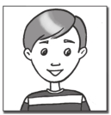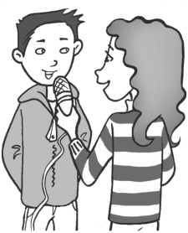

Worksheet Extra writing 1−3

1 Read about Jenny. Then read about Carlos and circle the missing capital letters.

Hi! I’m Jenny and I’m from Australia. I have two brothers. My birthday is in June. My best friend is Anh. She’s from Viet Nam. She has a sister.

hello! i’m carlos and i’m from brazil. my birthday is in august. i have a brother and a sister. my best friends are ali and josh. they’re from the U.S.A. they’re eight years old.

2 Match and write the contractions.

A B

I have I am she is
she has they are they have
she’s they’ve I’ve
I’m they’re she’s
1 I have

2 I am

3 she is

4 she has

5 they are

6 they have
I’ve

3 Read Amelia’s interview. Add punctuation marks (. , ?).

Amelia Hello. Do you and your family have any pets?
David Yes, we do. We have a rabbit, a cat , and a goldfish.

Amelia And do you like sports

David Yes My favorite sports are soccer basketball and volleyball

Amelia Does anyone in your family collect things David Yes My sister collects shells postcards and pins
Amelia Thanks Last question Where are you from David I’m from Mexico

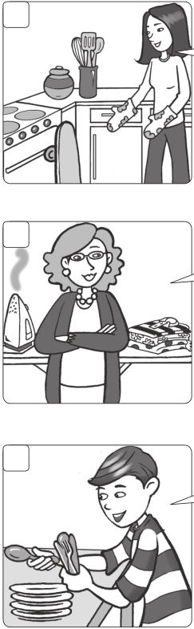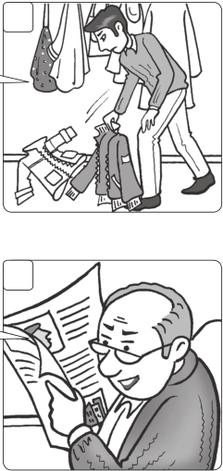

Worksheet
Values 1−3 Helpful and safe behavior

Match the beginnings and the ends of the questions.

1 Can you put your TV quietly, please?

2 Can you help me skateboard in your bedroom, please?

3 Can you help your clean clothes, please?

4 Can you watch me pick up the coats, please?

5 Can you take set the table, please?

Who says it? Write the questions.

1
Can you put your skateboard in
your bedroom, please?

2

3

4

5

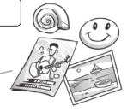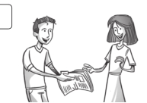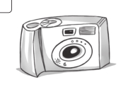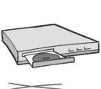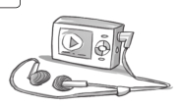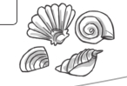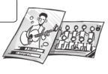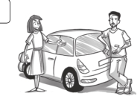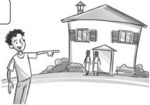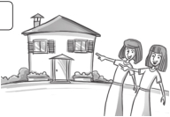

Test 3 Unit test

1 Circle. /3

1 2 3 4

DVD player / MP3 player / TV / CD player /

TV CD player camera TV

2 Write and match. /4

1 lcoctnioel collection c

2 nspi

3 starcdops

4 lesshl

5 restops

3 Write. our your their
a

d
b

e
c

/3

1 2

This is our car.
Is this newspaper?

3 4

That is That is

house. house.

4 Complete.

Mom Sam Mom Sam
Can I Can you you can Can I you can’t You can

1 Can you turn off the radio, Sam?

OK. 2 turn on the TV, Mom?

No, 3 . It’s too noisy.

4 use the computer?
/5

Mom Yes, 5 . 6 do your homework! /15

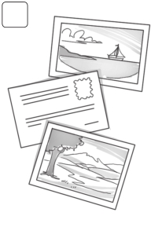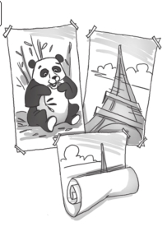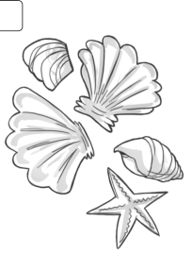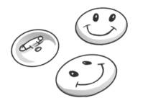

Test Summative test 1

1 Match. /7

1 visit d a gymnastics

2 read b the piano

3 do c photos

4 turn on d family

5 play e a kite

6 take f music

7 listen to g comics

8 fly h the TV

2 Circle. /3

1 2 3 4

shells / posters

3 Complete the sentences.
pins / shells

’m ’re ’s
postcards / shells
postcards / posters

/5

1 Where’s she from? She ’s from Australia.

2 Where are you from? I from Korea.

3 Where’s he from? He from Viet Nam.

4 Where are you from? We from Brazil.

5 Where are they from? They from Thailand.

6 Where’s she from?

She
from the U.S.A.

18

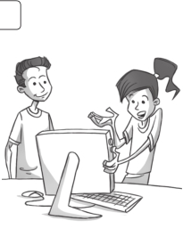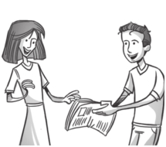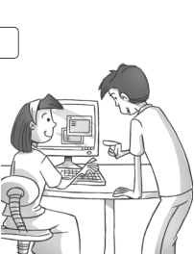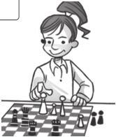

Summative test 1

4 Match.

1 Do you like cooking, Jane?

2 Does Harry like fishing?

3 Do you and Harry like playing chess?

4 Do Sam and Steve like taking photos?

5 Write the short answer.

d

/3

a No, they don’t. b No, we don’t.
c Yes, he does. d Yes, I do.

/3

1

3

2

4
1 Can I read your comic?

Yes, you can.

2 Can you turn on the computer?

3 Can you play chess?

4 Can I use your computer?

6 Listen and circle the letters you hear. 09 /4

1 play 2 crayon 3 snake 4 draw 5 spoon

7 Underline the words with magic e. /5

1

4
hat

cub
hate

cube

2

5
stone

rope
stop

rock

3

6
rip

fat
ripe

face

Family and Friends Special Edition Grade 5 Assessment and Resource Portfolio Review 1

19
/30

© Oxford University Press
Permission granted to reproduce for instructional use.


Test Skills test 1

Reading

3 Circle the correct word. /5

1 Children like reading these. books / comics

2 You take photos with this. CD player / camera

3 You wear lots of clothes at this time of year. winter / summer

4 This country is very far from England, but they speak English. Thailand / Australia

5 You do this in a lake or a river. fishing / gymnastics

6 People collect these on the beach.

shells / posters

© Oxford University Press

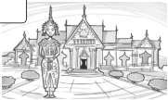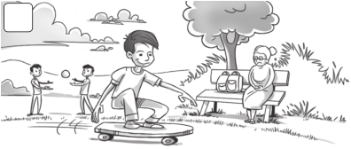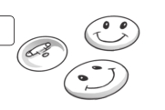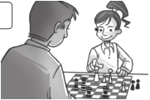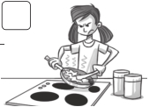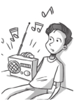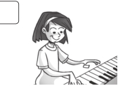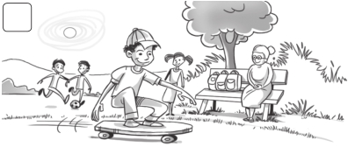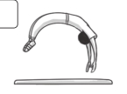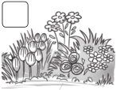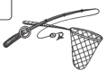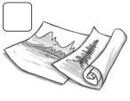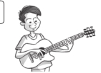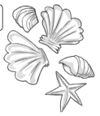

Skills test 1

4 Match.

/5

1 It’s spring.

2 I do gymnastics.

3 I have two posters.
b

a

b

c

4 I like fishing.

5 She has a shell collection.

6 He’s playing the guitar.

d

e

f

Writing

5 Look and write. /3

1 2 3 4

c o m p uter p n h l d p ay che s

6 Write the correct forms.

1
Carla likes playing (play) the piano.

3
Ian hates (listen) to music.

2

4

They love (shop).

I don’t like (cook).
/3

Speaking

7 Describe five differences between the two pictures.

A B
/5

In picture A it’s sunny, but in picture B it isn’t. /

