TOEFL
Primary
4

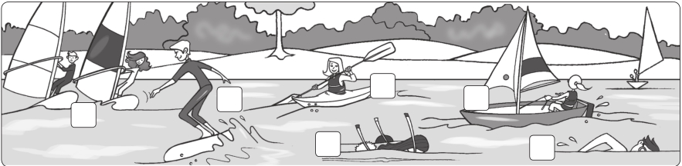
4

Worksheet Extra writing

1 Unscramble and write.

1 I love our apartment. 2 We don’t go to that beach.

It’s beautiful (ueablifut). It’s (lolutdep).

3 This is my favorite beach. 4 Look, that park doesn’t have any flowers.

It’s big and

5 That playground is
(lenac).
It’s
(guyl).

(erandougs).

We don’t play there.

2 Look and correct the sentences.

1 2 4 5

3 6

1 They’re kayaking. They aren’t kayaking. They’re windsurfing.

2 He’s swimming.

3 They’re sailing.

4 She’s snorkeling.

5 She’s waterskiing.

6 He’s surfing.

What’s your favorite sport?
Write a sentence and draw yourself.

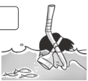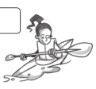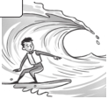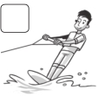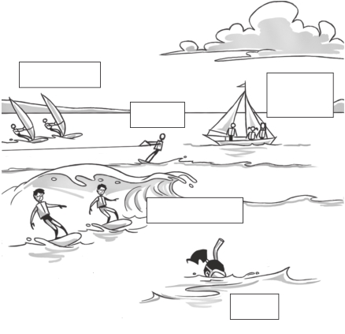

Test 4 Unit test

1 Complete the words.

1 cl e an 2 po luted

2 Write and match.

3 u ly

4 be utiful

5 dan erous
/4

/5

1 frus surf c a c

2 dinwurfs

3 ilsa

4 roksnel

5 yakka

6 skawtrei

d
b

e

f

3 Complete the sentences.

is are isn’t aren’t

/6

1 Ella is snorkeling.

2 Ed and Tim

3 The Lee family

windsurfing.

kayaking.

Ed & Tim

Chris

the Lee family

4 Chris waterskiing.

5 Rob and Tom

6 The Lee family

7 Ella

surfing.
snorkeling.

sailing.

Rob & Tom

Ella

