



Worksheet
4
Extra writing

Complete the words.
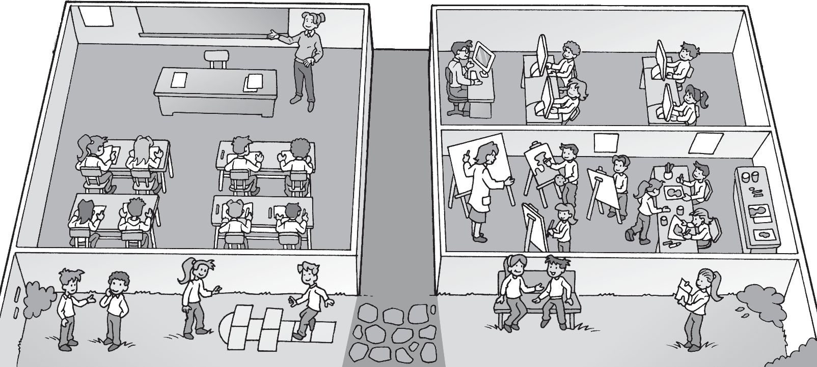
3 s c h l r d
4 a t r m
2 c p t r r m
1 cl a s s r oo m

- Write. Correct the sentences.
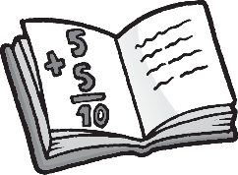
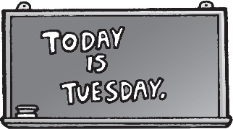


Monday
Tuesday
Wednesday
Thursday
English

  - We have P.E. on Tuesday.
No, we don’t. We have English on Tuesday.
  - We have English on Monday.
No, we don’t. on Monday.
  - We have P.E. on Wednesday.
No, we don’t. on .
  - We have math on Thursday.
No, we don’t. .


Worksheet
4
Values
Safety at school

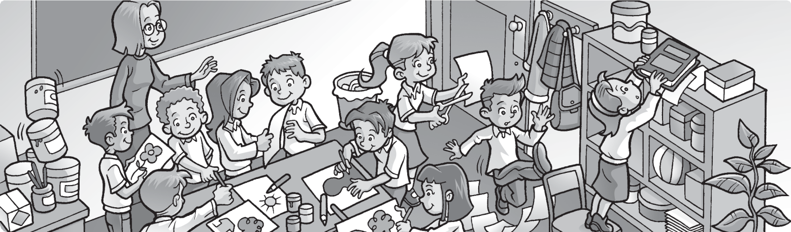


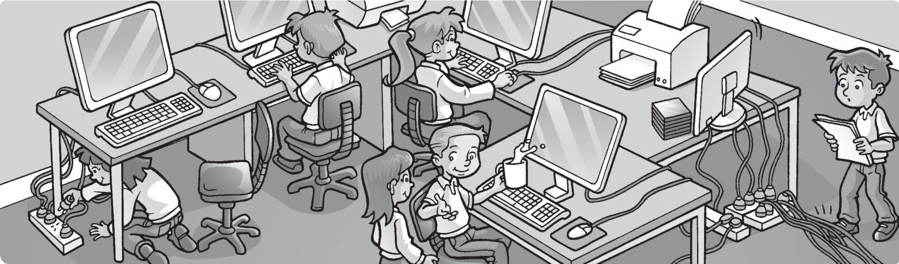

Is it dangerous? Circle.
1
2

- Complete your schedule. Write.
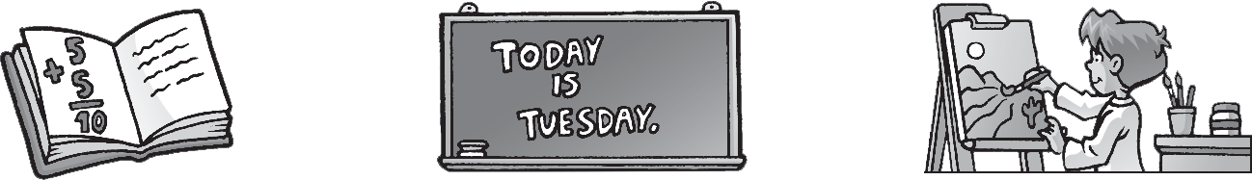

Monday
Tuesday
Wednesday
Thursday

  - We have on Monday.
  - We on Tuesday.
3
4
5

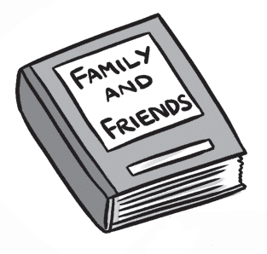
2
3
1
a r t
4
5
4
5





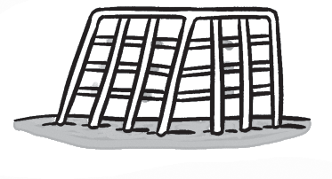



Complete and match.
/2
  - school yard b a

b
  - a t r m

c
  - c p ter room

Complete.

/3

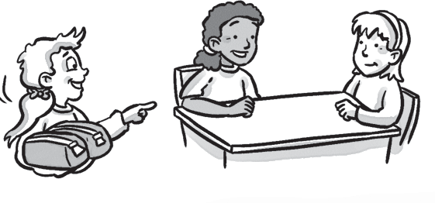
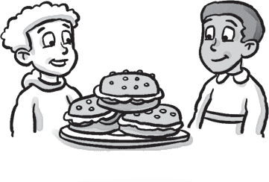
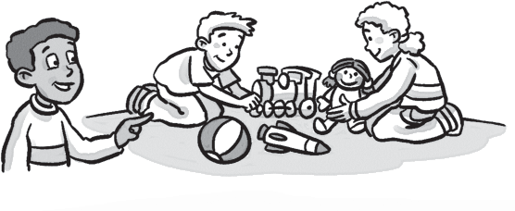
2 3 4
our their


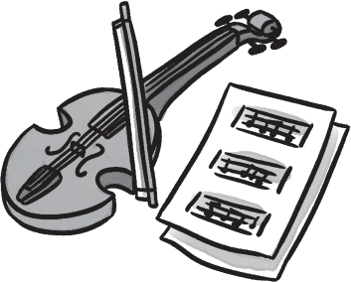
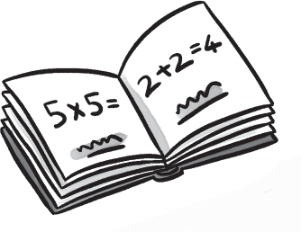
Test
4
Unit test
1 Complete the puzzle.
/4
1 2 3

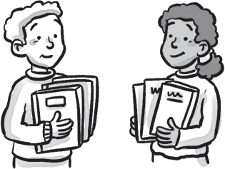
These are our These are These are These are books. pencil cases. toys. sandwiches.
1

Match.
/6
- What do we a music.
b
- Today we have b have on Tuesday?
- When do we c P.E. today.
- We have English d on Friday.
- What do e you have on Monday?
- I don’t f have math?
/15
- We don’t have g have art today.

