- Write the words. Find them in the wordsearch.
s | a | n | d | w | i | c | h | m
x | c | d | h | g | o | y | m | i
c | b | p | i | z | z | a | k | l
h | u | z | b | c | f | x | d | k
i | p | s | a | l | a | d | a | s
c | a | s | t | b | r | j | q | h
k | o | x | z | t | a | o | w | a
e | v | f | r | i | e | s | x | k
n | b | t | a | d | w | r | l | e


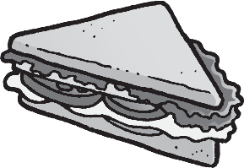


1
2
sandwich

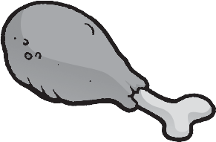


3
4



5
6

Write in the missing numbers.
10
20
30
1
ten, twenty , thirty,

Look and write.

2
seventy, , ninety,
70
90

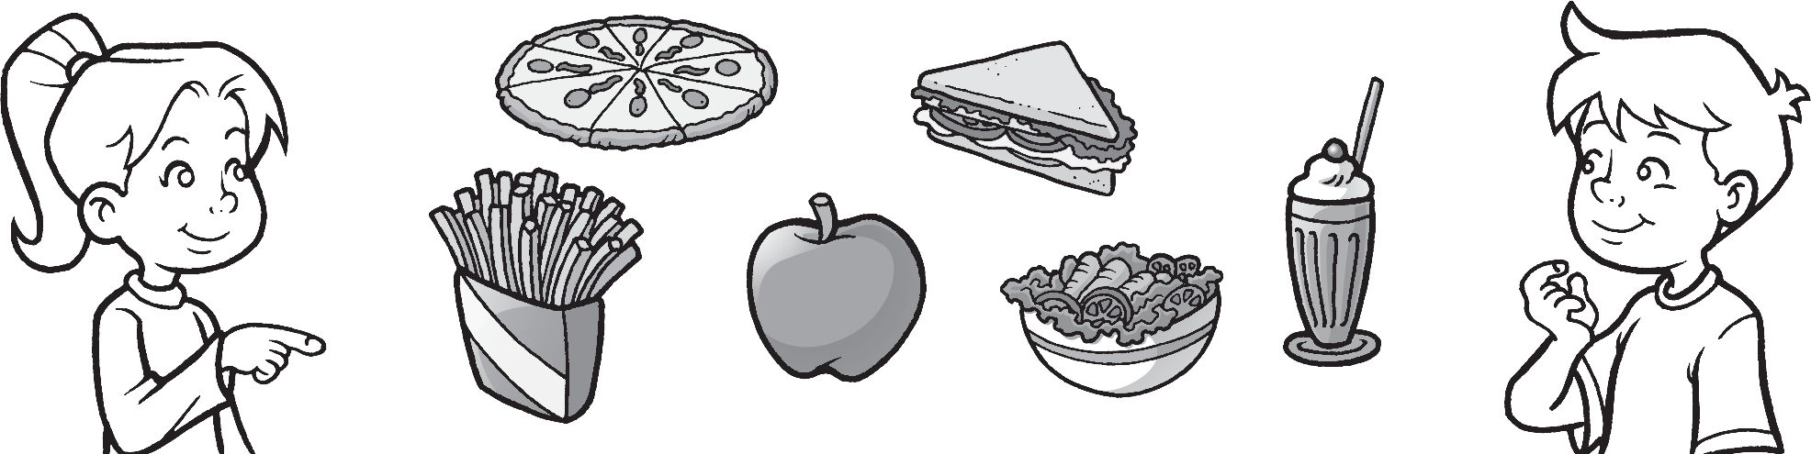

  - Does she have a pizza? Yes, she does .
  - he fries? 3 he a milkshake? 4 she an apple? 5 she salad?

Which meals are healthy? Add the points.
fries | 1
cheese | 3
salad | 5
fruit | 5
pizza | 2
milkshake | 3

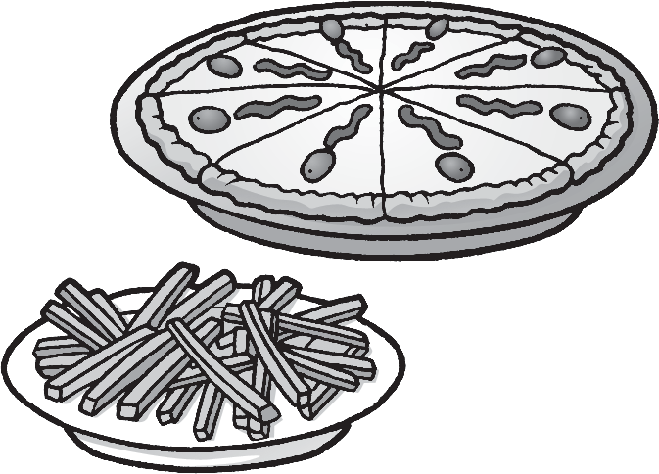
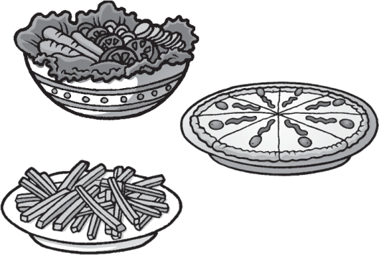
1
2

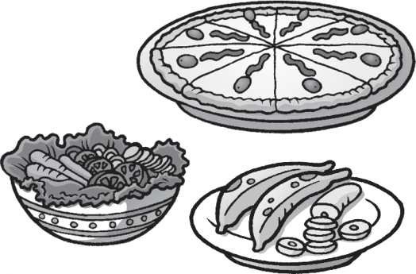
points. Unhealthy
3
3

points.
points.
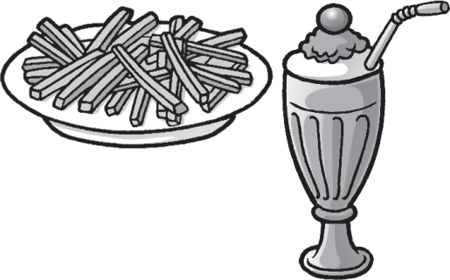
4
points.

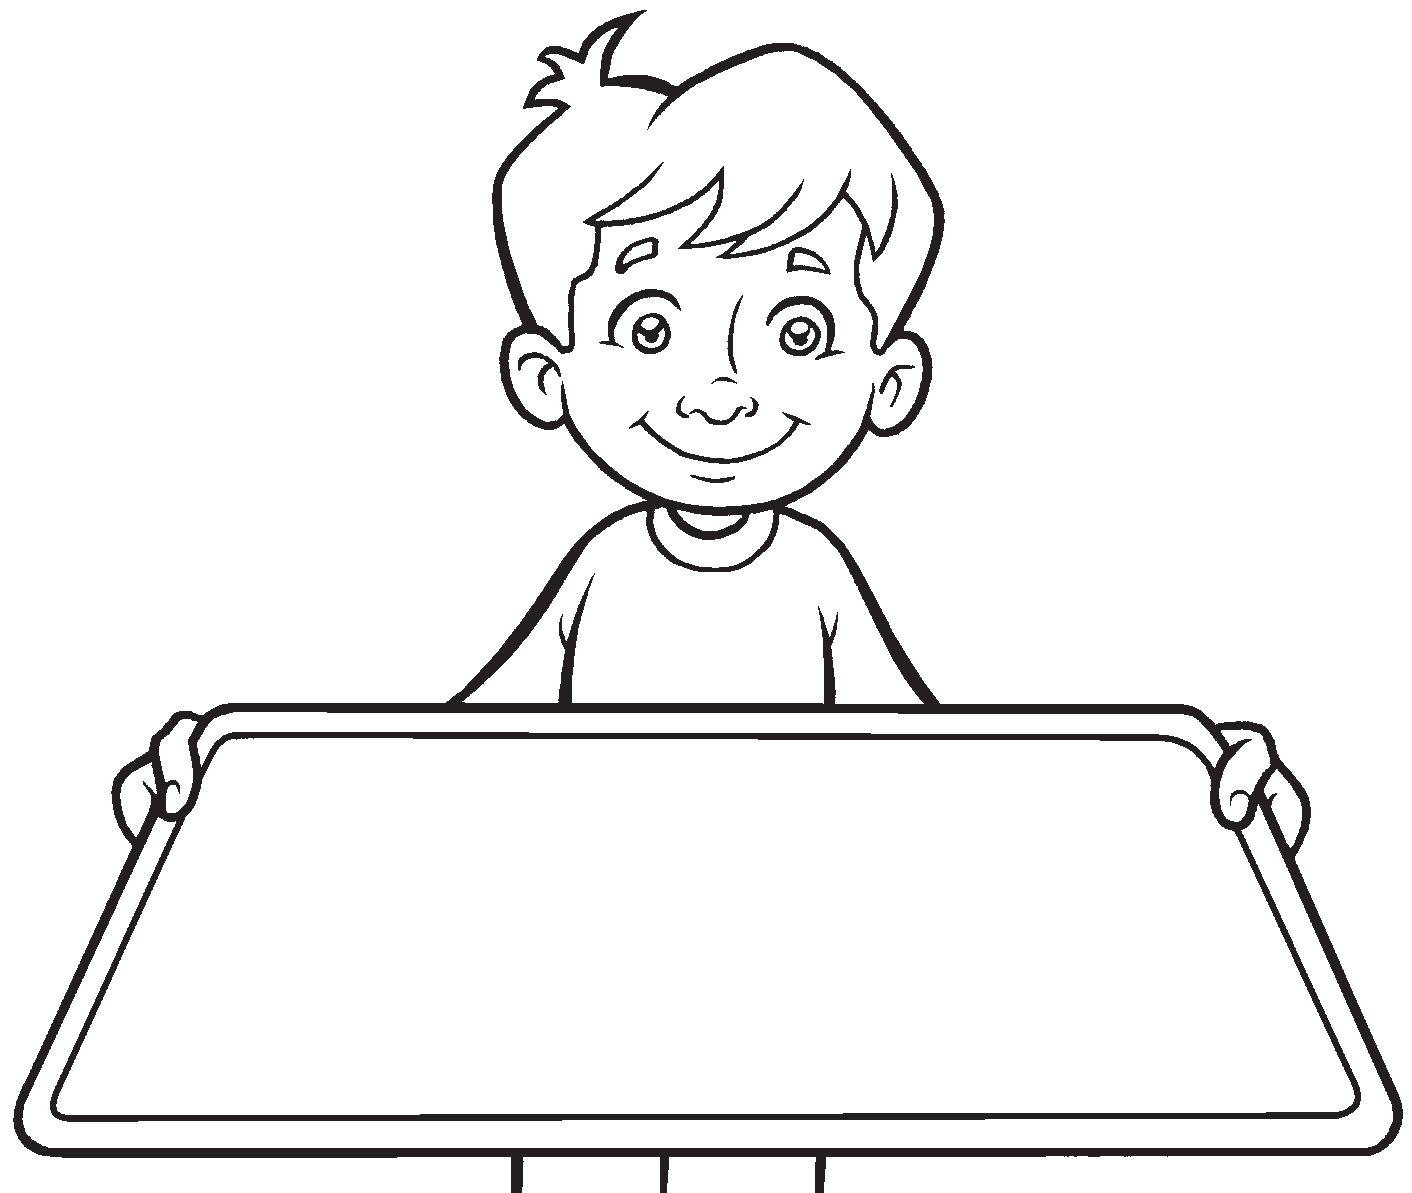
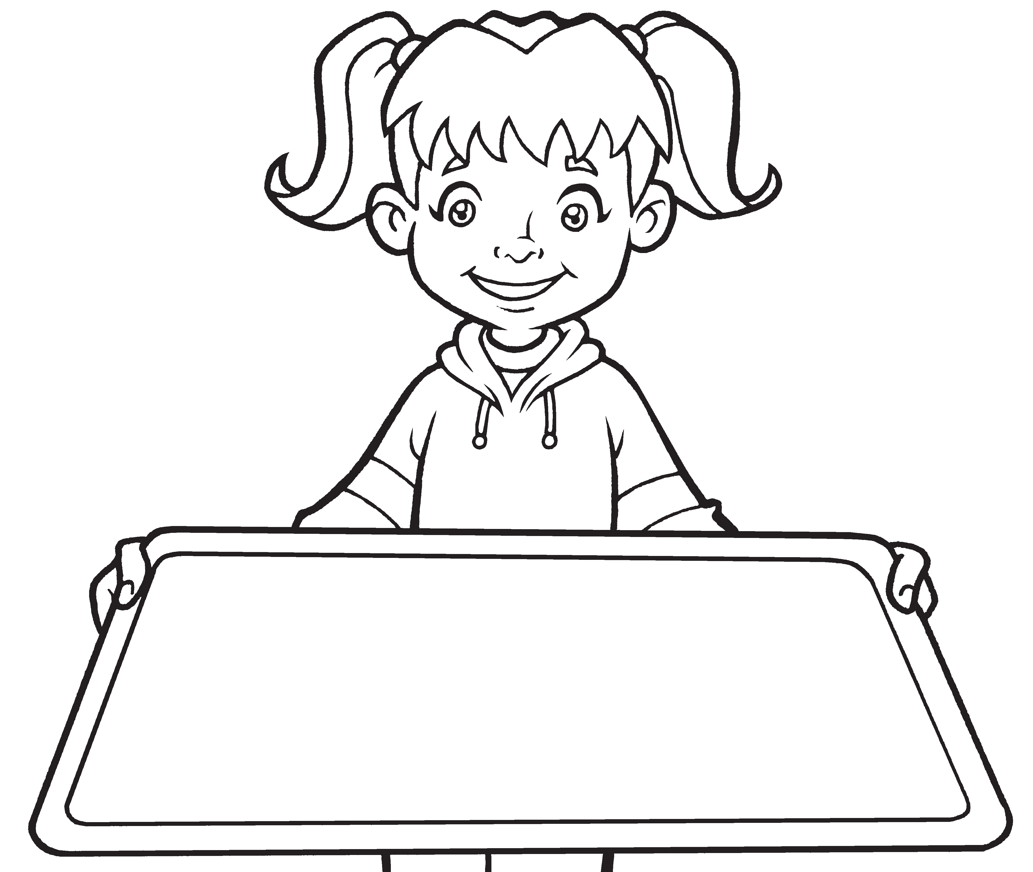
Read and draw.

1–5 Unhealthy
6–11 OK
12–20 Healthy


1 He has a pizza and fries.
Worksheet
3
Values
Healthy food
He has a banana.
2 She has chicken and salad.
She has a milkshake.

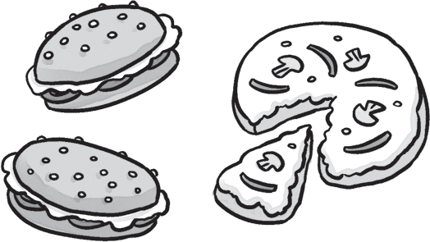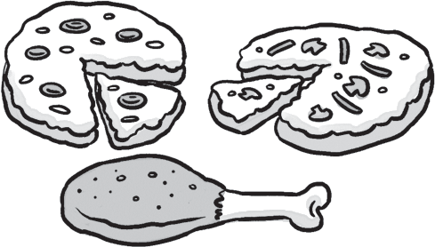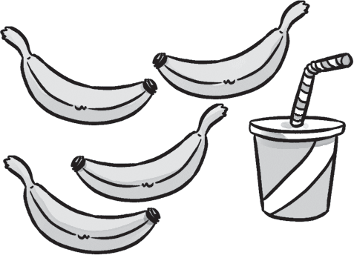
1 pizza 2 3 4

Match.
/4

1
c
2
3
4
5
forty
b twenty
c thirty
d seventy e ninety

a

Underline the correct words.
/5
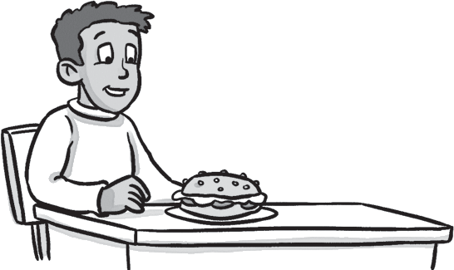
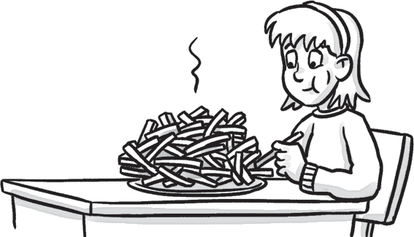
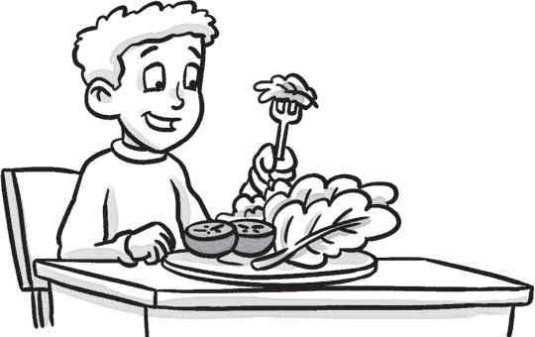
1
2
3

1 (Does / Do / Is) | 2 (Are / Does / Do) | 3 | (Is / Does / Do)
you have a pizza? | she have fries? |  | you have salad?
No, I (doesn’t / don’t / do). | Yes, she (does / doesn’t / do). |  | Yes, I (do / does / don’t).

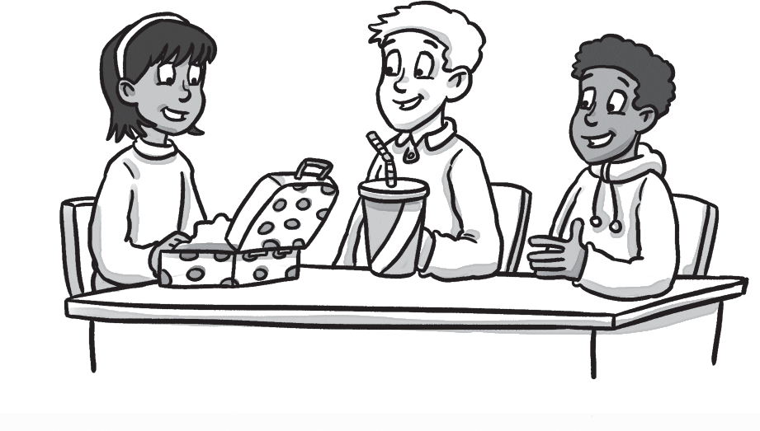
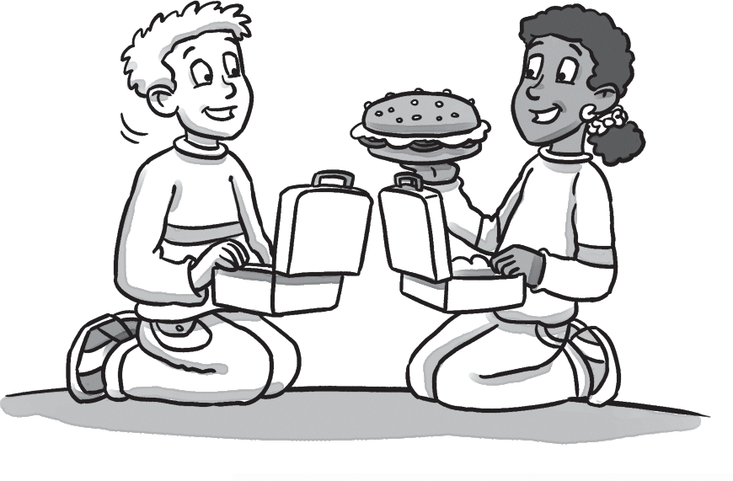
- Complete.
Do doesn’t have Yes

3 Does Erica a mikshake?
/3

1 Do you have a sandwich?
Test
3
Unit test
1 Circle the odd-one-out. Write.
/3

2 , I do. 4 No, she .

/15

Test
Summative test 1

Circle the correct word.
/2

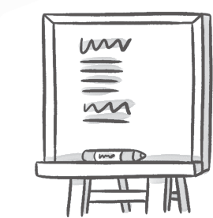

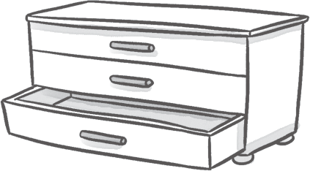

1 / poster 2 picture / computer 3 drawers / table
board

Look and write.
/4
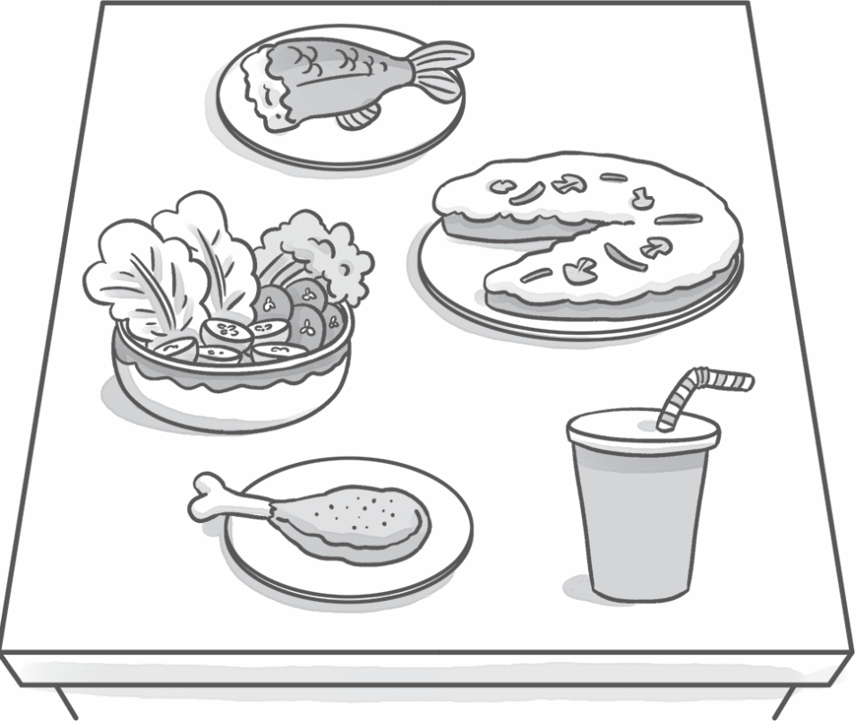
1 fish

3
2

4 5

Summative test 1


Match the pictures with the beginning sounds.
/5
4
1

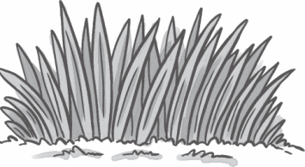
a
c
2
fr

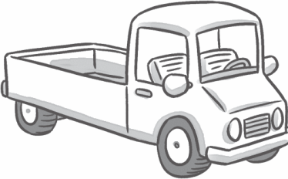
b
5
cr

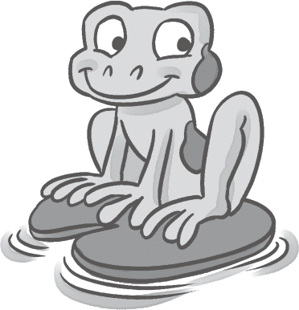
c
gr
d e
dr
br
3
6


f 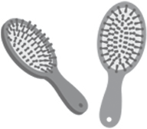
/5
tr

Write the words from 3.

1 | grass | 2 |  | 3
4 |  | 5 |  | 6


- Listen and circle the beginning sounds you hear. 09
/4
1 gr br fr 2 dr tr cr

3 gr br fr 4 dr tr cr
/20

Test
Skills test 1

Listening
1 Listen and write. | 10 |  |  | /5
1 30 | 2 |  | 3
4 | 5 |  | 6



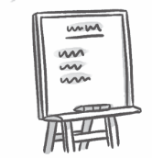

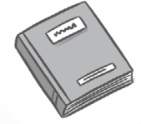

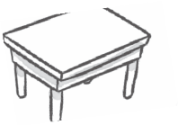


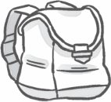

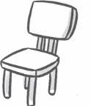
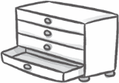
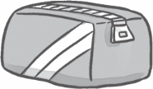


Listen and check (✔). 11
1
3
✔
2
4
/3

Reading
- Read. Circle the correct answer.
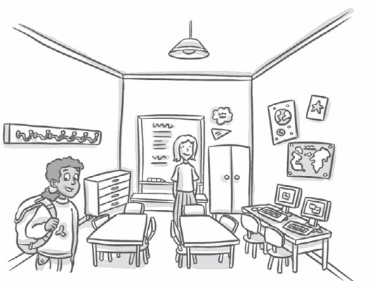

Hello! My name’s Daisy. I’m eight. This is my classroom. There are three tables and eight chairs. That is my teacher, Miss Green. She is in front of the board. There are two computers in my classroom. There are pictures on the wall. There are lots of coat hooks. My coat hook
/3
is blue. This is my bag, it’s yellow.

1 How many tables are there? three / four 2 How many chairs are there? nine / eight 3 How many computers are there? three / two
4 What color is Daisy’s coat hook? blue / yellow

Read again and write T (true) or F (false).
/4

1 Daisy is nine. 2 Miss Green is Daisy’s teacher.
F
3 There are pictures on the wall. 4 There are three computers.
5 Daisy’s bag is blue. 

Writing
Skills test 1

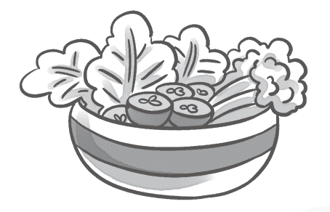
Look and write.
/5
1 lasda | 2 ckechin | 3 kmilshkea
salad

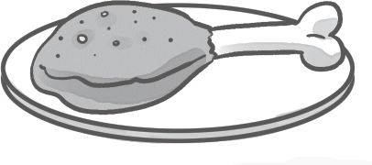


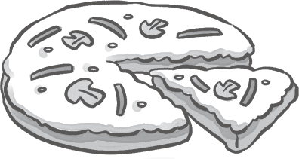
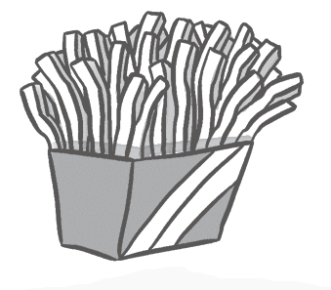
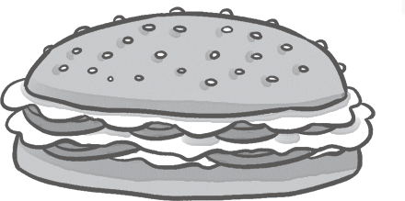
4 zzapi 5 ifres 6 wichands

Speaking

Look and say.
/5
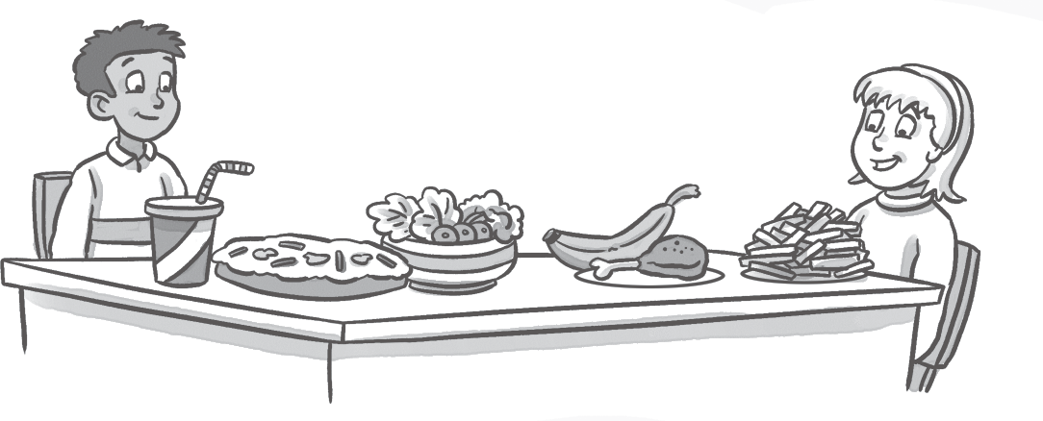
What do they have? He has

a pizza …

/30

