1 Look at the picture. Circle A, B, or C.
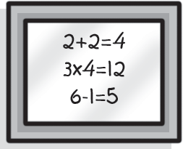
- This is a picture. This is a board.
Example
(B)
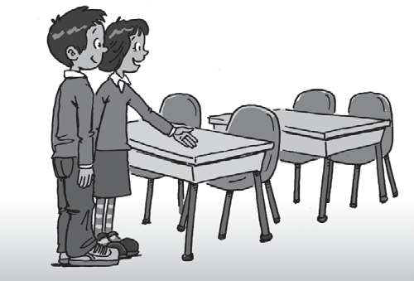
(C) This is a poster.

- (A) This is a computer.
- This is a chair and a table.
- These are chairs and tables.


- (A) This is a pencil case.
- That is a pencil case.
- Those are pencil cases.
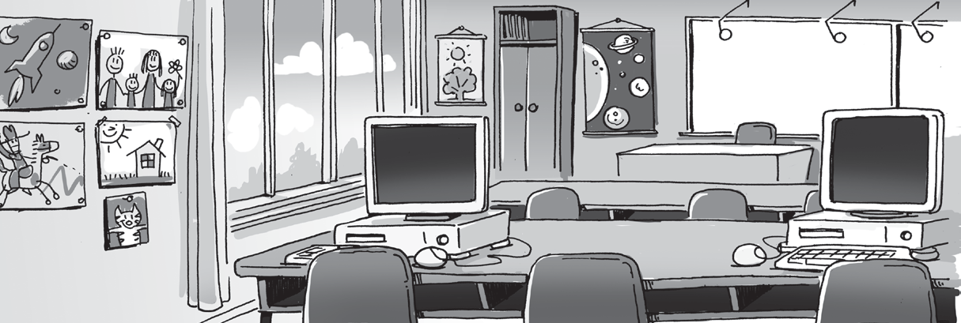
- (A) Those are our classrooms.
- This is our classroom.
- These are our classrooms.

- (A) There are long tables and computers. There is a big board and five pictures.
- There is a tall table and three computers. There is a big board and three pictures.
- The table is short. Those are computers on the table. There is a small window and three pictures.



Family and Friends Special Edition Grade 4 9
TOEFL
Primary
2
Reading
© Oxford University Press

TOEFL
Primary
Reading

Read and guess. What is it? Circle A, B, or C.
It’s long. It has lots of numbers. What is it?
Example
(A)
It’s a ruler.
- It’s a coat hook.
- It’s a computer.

  - It is in my bedroom. My clothes and toys are in it. What is it?
    - It’s a bed.
    - It’s a cabinet.
    - It’s a pencil case.

  - I can read, write and play games with it. There are five in my classroom. I have one in my house.
What is it?
    - It’s a coat hook.
    - It’s a toy.
    - It’s a computer.

  - It is big and bright in here. There are pictures and posters on the walls. I study with my friends here.
Where is it?
    - It’s an apartment.
    - It’s a student.
    - It’s a classroom.

TOEFL
Primary
Reading

Read and answer the questions. Circle A, B, or C.
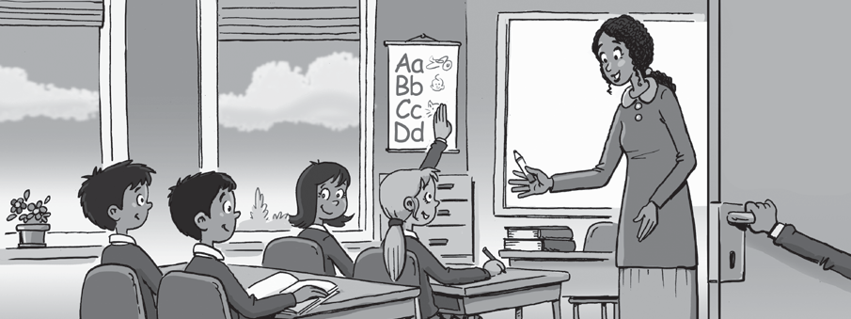
Welcome to our classroom! This is Class 3G. There are lots of students in my class. There are seven boys and nine girls. That’s me, Helen. I am with my friend Jane. That is our teacher, Ms. Brown. She is very kind. There is an ABC poster on the wall, and a big board. There
are two big windows and six computers. Our classroom is very bright. I hope you like Class 3G’s classroom. I love it!

What is the teacher’s name?
Example

(A) Ms. Helen Ms. Brown (C) Ms. Jane
(B)

- How many students are there in Class 3G?
  - There are seven.
  - There are nine.
  - There are sixteen.

- What is in the classroom?
  - There is a poster and a board. There are computers, too.
  - There is a poster. There isn’t a window.
  - There is a board, windows and a television.

- Does Helen like the classroom?
  - Yes, he does.
  - Yes, she does.
  - No, she doesn’t.


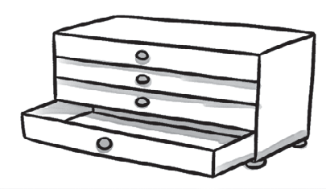
- Join and write.
/3
com
wers
dra
ter
pos
puter
coat
hook
1 computer 2

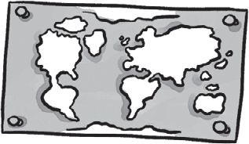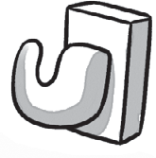


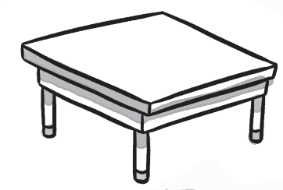





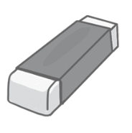




Look at the pictures. Complete.
3
2
5
1
2
3
1
3 4
/4

Test
2
Unit test

p | i | c | t | u | r | e
4

5

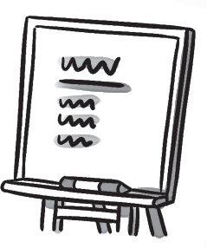
Complete.
/5
4
is
are
1 This is my coat hook. 2 Those my pencils.
3 These my books. 4 Those my pens.
5 This my chair. 6 Those new tables.

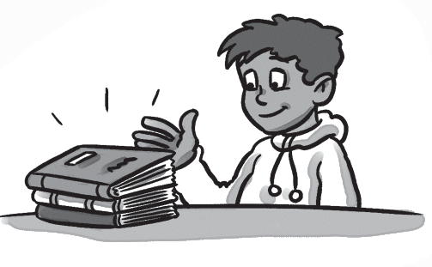
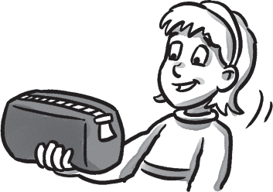
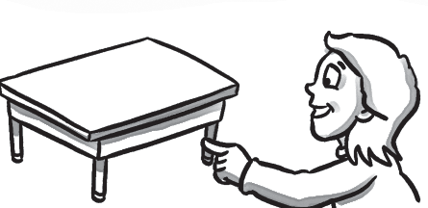
Look and write.
2
3
4
This That These Those
/3
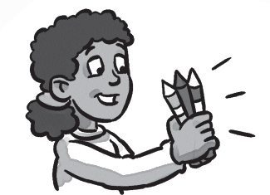
1
1 These are my pencils. 2 is my pencil case.
3 is my table. 4 are my books.
/15

