
TOEFL
Primary
2
Reading


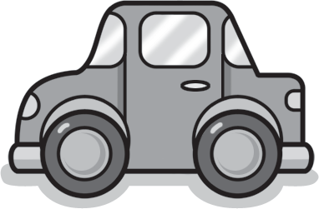
Look at the picture. Circle A, B, or C.

Example | (A)  (B)  (C) | A teddy bear A doll  A kite
1 | (A)  (B)  (C) | This is my train. This is my bike. This is my car.
2 | (A)  (B)  (C) | This is your bike. This is my bike.  This is my teddy bear.

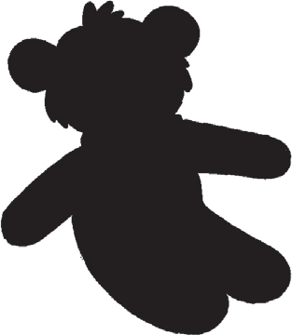
  - 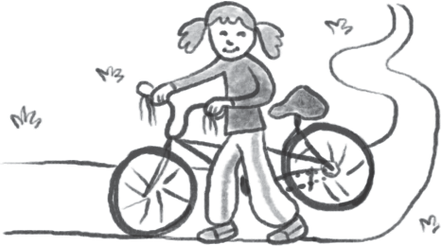Is it a kite?
    - No, it isn’t. It’s a teddy bear.
    - Yes, it is. It’s a kite.
    - No, it isn’t. It’s a ball.

  - 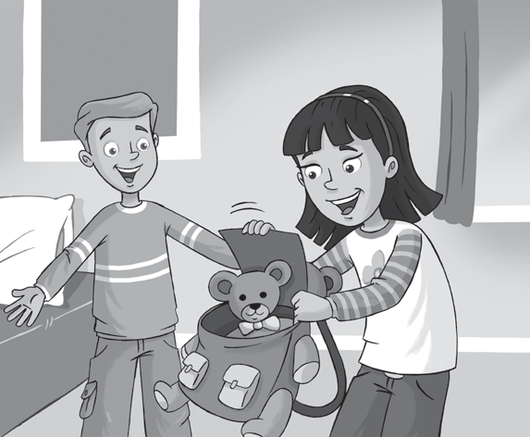Is this your teddy bear?
Is this your teddy bear?
    - No. It’s my bag.
    - No, it isn’t.
    - Yes, it is.

TOEFL
Primary
Reading

Read and guess. What is it? Circle A, B, or C.
It’s a toy. It’s long and red. What is it?
Example
(A)
It’s a train.
- It’s a dog.
- It’s a bike.

- It’s an animal. It’s big. It’s black and white. What is it?
  - It’s an egg.
  - It’s a zebra.
  - It’s a ruler.

- It’s my favorite color. My cat is this color. What is it?
  - Blue
  - Animal
  - White

- It’s my favorite toy. It’s small and brown. What is it?
  - It’s your teddy bear.
  - It’s your pencil.
  - It’s your fig.

TOEFL
Primary
Reading

3 Read and answer the questions. Circle A, B, or C.
Hello! My name is Kim. This is my favorite toy. It’s a car. It is black and red. I love my car! This is my favorite animal. It’s my black cat, Jake. My favorite color is black!

What is the girl’s name?
Example
- Toy Kim
(B)
(C) Jake

- What is Kim’s favorite toy?
  - A car
  - A cat
  - An animal

- What color is Kim’s favorite animal?
  - Black
  - A cat
  - Black and red

- What is Jake?
  - A toy
  - A color
  - A cat

Match and write.
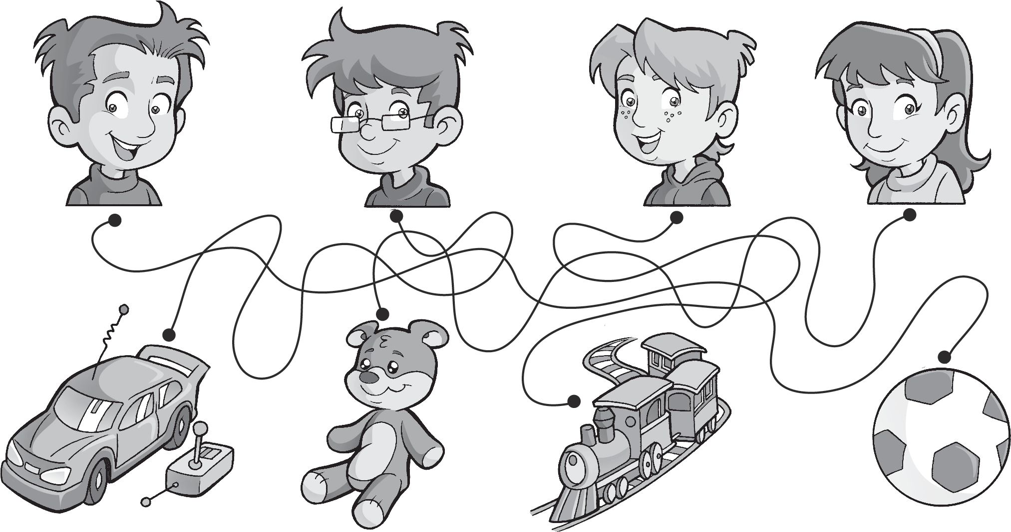
1
2
3
4

1 This is my ball .
3 This is my .
2 This is my .
4 This is my .


Worksheet
2
Extra writing

Look and write.
Yes, it is. No, it isn’t.
  - Is this your 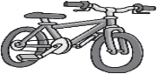 bike ? Yes, it is.
  - Is this your 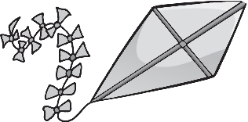 ?
  - Is this your 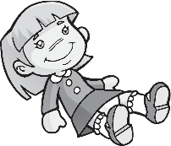 ?
  - Is this your 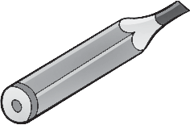 ?
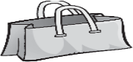
  - Is this your ?

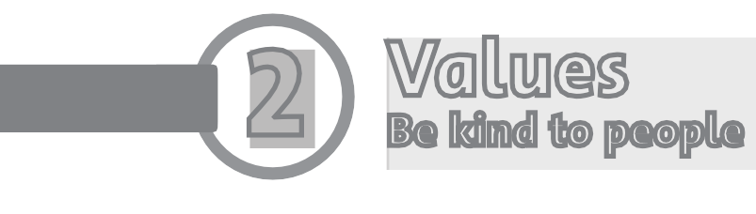
Worksheet
2
Values
Be kind to people
1 Look and draw.

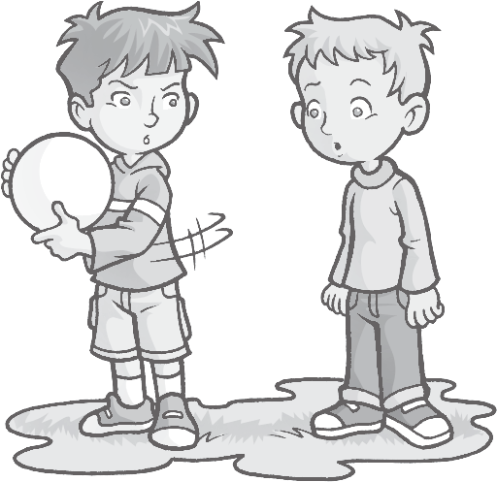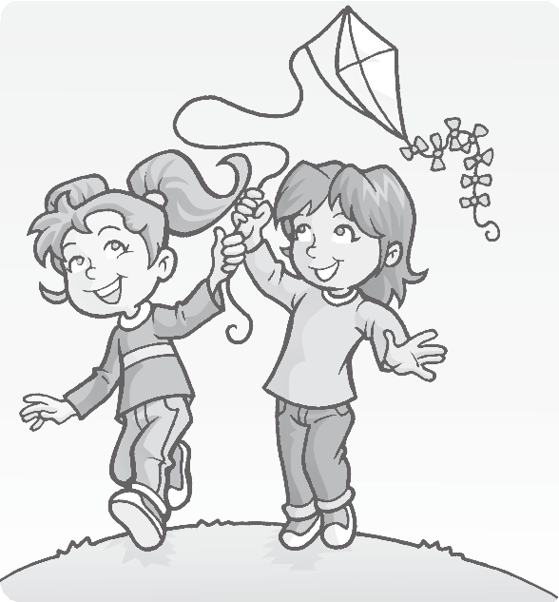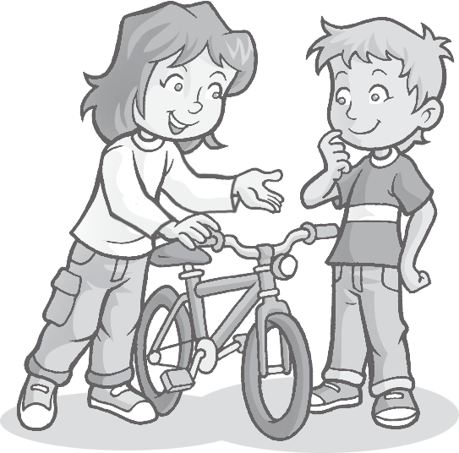
1
2
3
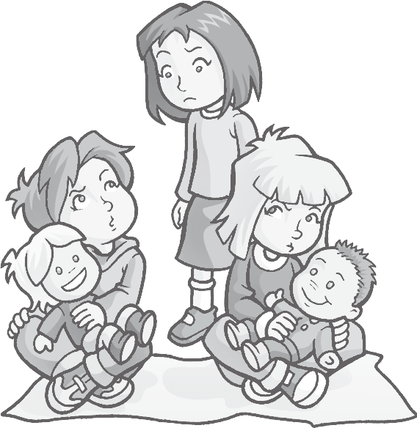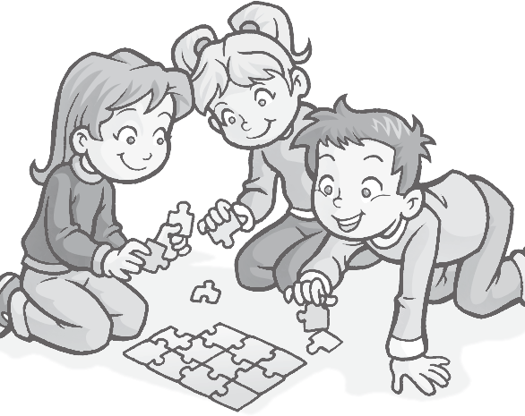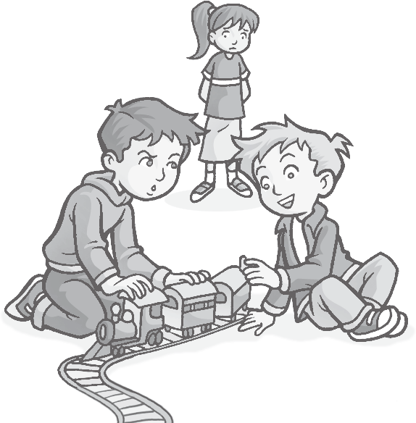
4
5
6

2 Choose a toy for your friend. Draw and color.
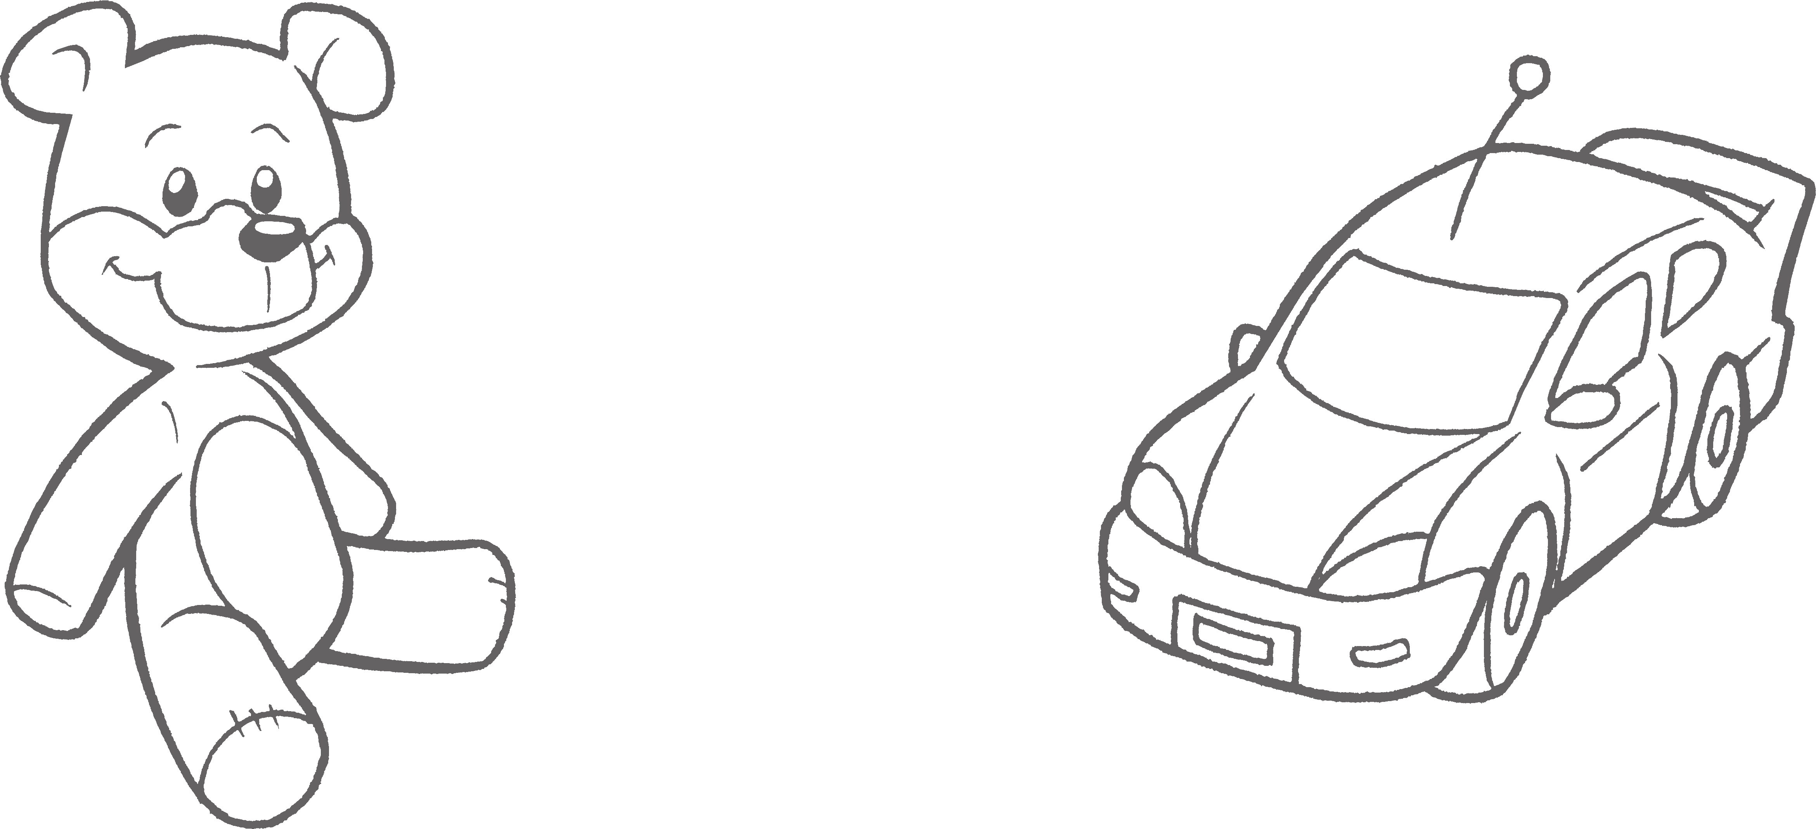

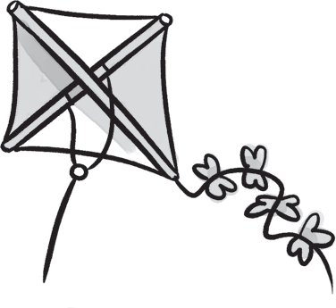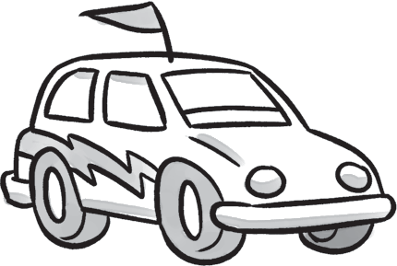
- 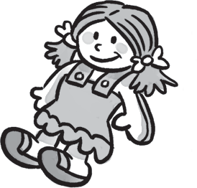2 bike / kite 3 car / hat 4 doll / ball

doll / train

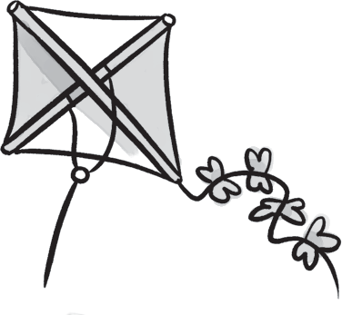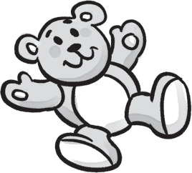Write and match.
/ 4
  - i k e t kite

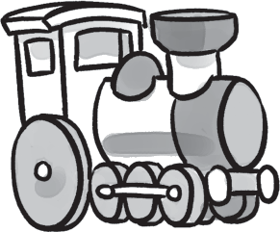
  - o l d l

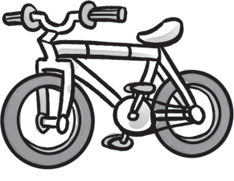
  - n t r i a 4 d t e d y r a e b 5 i k e b

Order the words.
1
This
bike.
is
my
2
it
Yes,
is.
3
my
This
kite.
is
4
your
Is
this
train?
5
isn’t.
it
No,
6
this
your
bag?
Is

Complete the answers.

This is my bike.
/ 5

/ 3

- 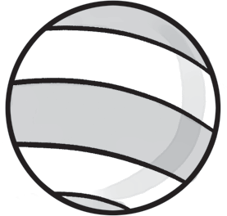Is this your teddy bear? Yes, it is .
Test
2
Unit test
1 Circle the correct word.
/ 3
- Is this your doll? No, it .
- Is this your hat? No, .
/15
- Is this your train? Yes, .

