REVIEW
GRDAE 2 : TINY TALK 1B
UNITS 1-2-3
Full name: ______________Class: 2/__
EX1: . Look, read and write into the sentence:( Nhìn, đọc và viết thành câu)
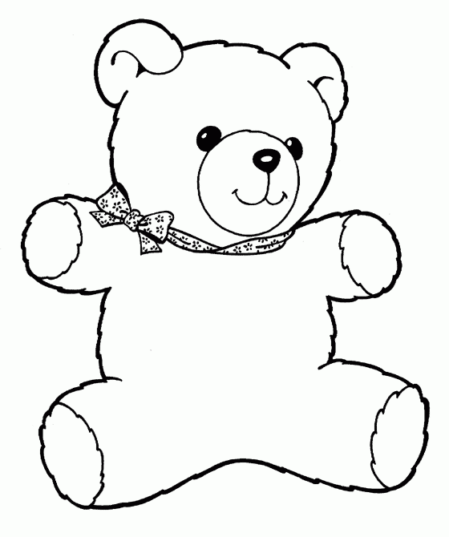 | Sue: That’s my bear.  Benny : No, It’s my bear.
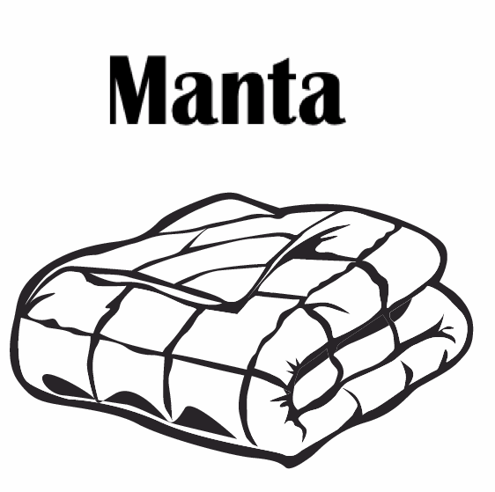 | Sue: _________________  Benny: _______________
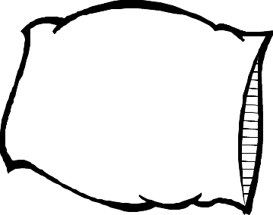 | Sue: _________________  Benny: _______________
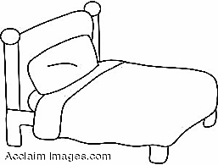 | Sue: _________________  Benny: _______________

EX 2:Look and write the words (nhìn và viết lại)
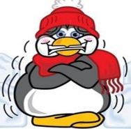

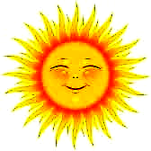
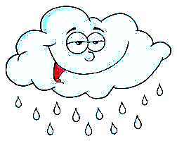
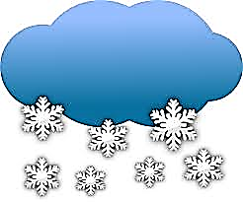
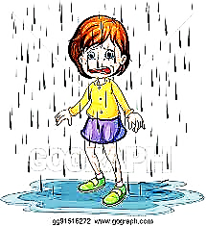  sunny | 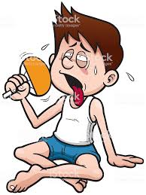  _________ | 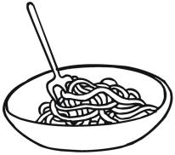  __________ | 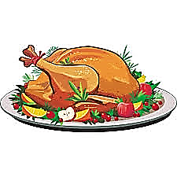  __________ | 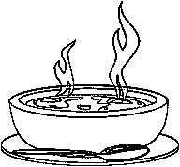  _________
_________ | _________ | _________ | ___________ | __________
 |  |  |  | 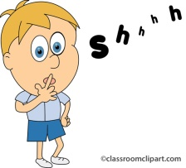
 |  |  | 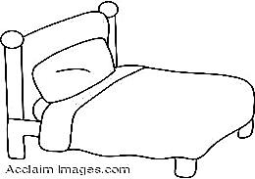
___________ | __________ | _________ | __________ | Be quiet !_

EX 3: Choose the best word: (chọn từ đúng)
Pillow Be quiet! Bear blanket bed

1. bear | 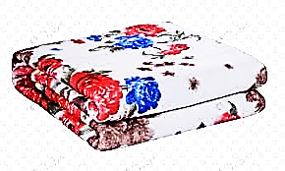  2. ------------------ | 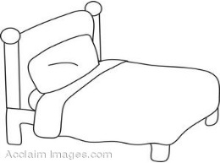  3. ------------------ | 4. ------------------ |   5. ------------------

EX 4 : Choose the best answers: (Chọn đáp án đúng)

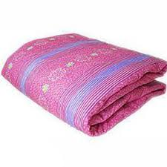  1. It’s my _____  a. blanket  b. bed  c. Be quiet! | 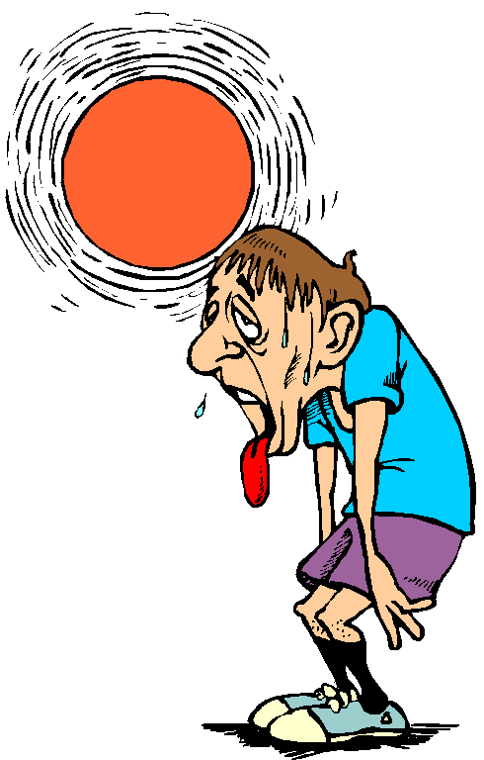  2. I’m ________  a. hot.  b. wet.  c. sunny. | 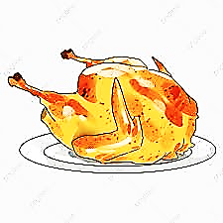  3. Have some _____  a. hungry  b. soup  c. chicken
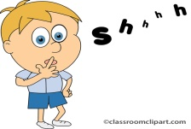  4. Be _____  a. quiet!  b. cold  c. blanket | 5. It’s _________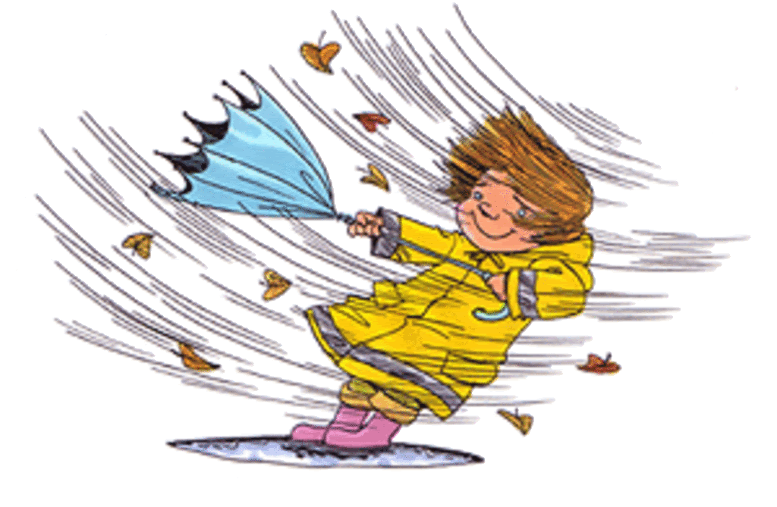  a. cold.  b. windy.  c. hungry. | 6. It’s my _____  a. noodles  b. bear  c. pillow
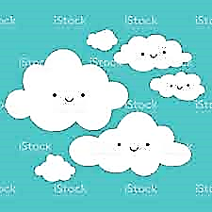  7. _____ cloudy.  a. I’m  b. It’s  c. cloudy | 8. Have some_____ 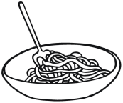  a. noodles  b. cold  c. chicken | 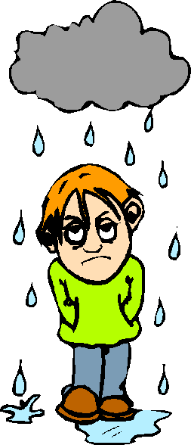  9. I’m _______  a. raining.  b. snowing.  c. wet.
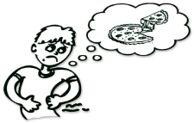  10. I’m_______  a. cold  b. hungry  c. wet |   11. It’s _________  a. chicken.  b. cloudy.  c. snowing. | 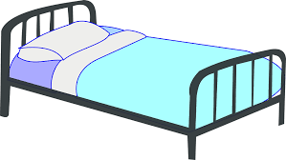  12. It’s ____ bed.  a. I’m  b. bear  c. my
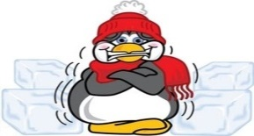  13. _____ cold.  a. I’m  b. It’s  c. Be quiet ! | 14. It’s my _____  a. bed  b. bear  c. pillow | 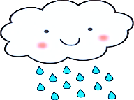  15. It’s _________  a. sunny.  b. wet.  c. raining.

THE END

